Chet Blascziek
Holdingford Classs of 1962

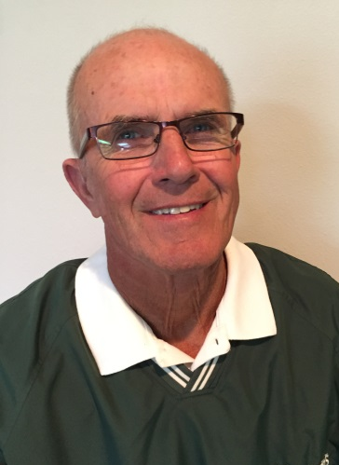
Chet was born May 29, 1944 in the country near St Anna. He was the youngest of 4 born to Regina, his mother and father Stanley who lived in the area nearly their entire life. The most influential person in his life was his mom, who brought him up to respect life and all it has to offer.
Chet was introduced to athletics during his 7th and 8th grade years at the two room elementary school in St Anna. The local priest, Fr Pedrowski, started a youth basketball team with games being played at the Holdingford High School gym, this was the beginning of his love affair with athletics. In 1958, as an in-coming freshman he was introduced to other sports, baseball, football and track and field and has been involved with HHS athletics ever since. During his high school years he was all conference player in basketball, track and field and baseball earning 15 letters and competed in the State Track Meet earning all-state honors in the hurdles his senior year . In high school he was most influenced by his high school head football and track coach Bob Theis. “Bob taught me there was more to athletics then just winning.” His love for athletics led him to St John’s University, where he participated in track and was coached by John Gagliardi and also played basketball for one year, he then transferred to St Cloud State University where he was coached by Bob Tracy and was named captain for the Track and Field team his senior year and the next year was a grad assistant for Coach Bob Tracy. “My two college coaches gave me insight as to coaching style and technique, my wife, Rose, and my family allowed me to pursue my dream of coaching.”
While in college he married Rose, also a Holdingford High School graduate and homecoming queen, then accepted a teaching position at Holdingford in the fall of 1967 as a social studies, Physical Ed and health instructor. Coaching duties included head Cross Country, assistant basketball and head track coach. As a new coach he was encouraged to get a struggling Track and Field program going and by the third year the team won the conference title and were conference contenders every year after that never placing lower then second in his head coaching career. During the next 37 years HHS the boys won 31 conference titles.
While at HHS Chet served as head coach for four sports, Track and Field boys only, boys and girl’s Track and Field, Cross Country and girls swimming, assistant boys basketball and football coach as well as coaching 7th, 8th, and 9th grade football. While coaching Track and Field he coached 66 athletes in 74 events at the state meet, coached 7 athletes to state championships, and 36 athletes to top 10 finishes. Chet was named Region and District coach 6 times. He was also named the first Head Coach of the Year to Central Minnesota Conference.
Chet also served as Activities Director during his tenure. During this time, the athletic fields were updated including, a new track, new football field lighting, softball and baseball fields, and an updated wrestling room.
My passion for coaching continues to come from the great athletes I have coached. The athletes have come and gone but all of the great student athletes have taught me so much through the years and given me so many wonderful memories. I will be forever grateful to all of those men and women.
Currently, Chet is involved as an assistant coach for Track and Field and helps with the football team.
Chet and Rose had two sons who participated in several sports at HHS and went on to play basketball at SJU but now focus their time and attention on their grandkids. They spend a lot of time driving to the south metro area to cheer their 8 grandkids who compete for the Lakeville North Panthers. When they are not on the road you might see them up at the school.
“The best decision of my life was staying with my Holdindford roots. GO Green “

