Holdingford Elementary School
Principal’s Newsletter April 2017
Dreamcatcher II
Creating a New Play Space for All Children and Our Communities
This August we will be saying goodbye to the old Dreamcatcher playground and working together as a community to building a new playground. Please know we have worked extremely hard with our children to keep the welcoming and creative beauty of the Dreamcatcher when planning our new playground. Because we are greatly out of safety compliance and because the Dreamcatcher is rotting from the top down and bottom up, we feel it is time to create a new play space that will expand our littlest Husker playground, generate more active and creative play spaces for all students and visitors, while preserving the Dreamcatcher charm and entrance. Please know as your Preschool -6th grade principal I will do my best to make this an activity that pulls our communities, children, and families together. Please support our school and our children. Together we create a brighter future and a safer, healthier, happier place to learn, laugh, and grow!
Sincerely,
Jim Stang, Holdingford Elementary School Principal
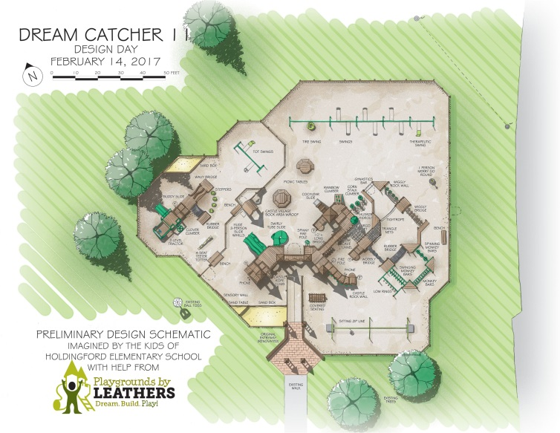
Dreamcatcher II Community Build…Ways to contribute and help:
- Preschool - 6th grade Fun Run, May 25: “Running to Catch My Dreams.” Sponsor your child to participate in our Fun Run Fundraiser. I will start running/training Monday, April 3rd and my fundraising goal is $500! Stang family and friends…you have been warned! My children and school need your support!
- Businesses will be asked to donate $ to our Dreamcatcher II playground and can help with our community build.
- Buy a “playground picket” dedicated to your family, business, or organization.
- Grandparents’ Day Silent Raffle Gift Baskets. (Principals/Superintendent Basket…S’more Fun with a FFA Husker Fire Ring)
- More Details to Come! Thank you for your support. Our elementary fundraising goal is $75,000! Many hands make light work! Together we can do great things for our children and our families!
FAMILY HELP WANTED! HELP NEEDED! FAMILY HELP GREATLY APPRECIATED!
- Review bus safety: Less is more! Do not bully! If you see or hear a bully, tell the bus driver. Ask your child if they stay out of the bus aisle? Do they stay seated and facing forward at all times? “Sometimes” is not good enough. Does your child use their quiet voice while riding the bus? Ask your child about their behavior while waiting at the bus stop. And last, but certainly not least, talk to your child about the language they use and hear on the bus. Set the standard and teach your expectations of appropriate words. Simply put, the primary concern of our bus drivers is safety. Tell your child to do their part and make good bus behavior contagious! Together we will keep our children safe and healthy!
- Hallway and cafeteria: We revisited our hallway and cafeteria manners and behaviors during the month of March. Please support our efforts by asking your child to walk in the hallway, stay to the right, turn outside voices off while walking throughout the building, and then thank them for us! Our kids did a super job of creating a better learning environment! Thank you, students and staff! I am proud to be your principal!
- If transportation changes occur during the school day, please let us know as soon as possible. Last minute changes can be very stressful for students, staff, and bus drivers. Thank you.
- When dropping children off at school: Please try to drop your children off as close to 7:40 as possible. When picking children up at the end of the day, you will notice that we are not letting children wait outside by the front doors and sidewalk. It is way too congested and unsafe. From now on, all children will need to be seated in the hallway until a parent or family member picks them up. Please help us and talk to your children again about making appropriate choices while waiting to be picked up. It is a really busy time for the office staff, and Ms. Sharon could use your help in keeping everyone safe. Thank you!
- Please set time aside nightly to share a good book or provide a quiet place for your child to read by themselves. Turn off the TV while completing homework and studying for spelling. Check your child’s agenda and take home folders. And if the weather ever turns nice…please remember to hold bedtimes sacred, and please make sure to get your children to school every day unless sick with viable signs of illness.
- TOGETHER WE MAKE A DIFFERENCE! TOGETHER WE MAKE LEARNING A LIFELONG ADVENTURE AND TOGETHER WE WILL KEEP OUR CHILDREN GROWING!

MCA Testing Dates and Tips:
  - April 3 – 21 Grades 3-6 Reading
  - April 24 – May 5 Grades 3-6 Math
  - May 8 - 12 5th Grade Science
Again this year our teachers and support staff have worked tirelessly to present curriculum and state standards to ensure academic success and pique student interest. There are too many to thank individually, so I will simply, but with great sincerity and respect, say thank you to my AMAZING staff. You make work and learning fun! I would also like to thank my families and students for supporting us. The rigor of schooling has increased greatly in the last decade and family time is at a premium, and yet day in and day out, you support us with countless hours spent reading, practicing math, spelling, and studying for tests. It is our relentless pursuit of making our community a better place to live and laugh that we discover that we are in this together to create a better tomorrow!
Your Holdingford Husker Family is proud of the fact that our students continue to have some of the highest overall proficiency rates in math, reading, and science when compared to state averages and neighboring districts. With your help and encouragement, we pursue even better test scores and continue to educate all children to achieve social, emotional, and academic success. Please support our mission by getting your child to sleep and school on time. Give them the love and structure they need to get 8-9 hours of sleep every night. Thank you!
Grandparents’ Day:
Our annual Grandparents’ Day is scheduled for Friday, May 12, from 10:00 am – 1:20 pm. Please reserve the time and date. I can’t wait to meet and greet our grandparents! This day is a family celebration of Husker Spirit and Husker Family Values! We love sharing our school and classrooms, and we are looking forward to another Grandparents’ Day full of learning and family fun!
Spring Book Fair! Buy 1 Get 1 Free! May 8-12
The week of May 8-12 from 7:30 am to 3:30 pm, Holdingford Elementary School will be hosting a Spring Book Fair. Proceeds from book sales will go directly to purchasing books for our Elementary Library! Please stop on in, buy a good book or two for summer reading, and support our Spring Book Fair! A huge Husker “Thank You” goes out to our supportive and dedicated PTA for organizing this event. We truly appreciate your positive Husker energy and support!
Get “Hooked” On Summer Learning!
Summer School 2017: July 10-28
For those families still considering attending summer school, please get your application in soon. We will be creating class lists and hiring staff soon and need to know summer school numbers. Please call me if you have any questions or concerns regarding our program. Having taught summer school for 15 years, I can honestly say it is a GREAT program for children and families. Skills necessary for literacy and numeracy get remediated in a more relaxed learning atmosphere with small numbers of children receiving one on one or small group instruction.
Busing is provided
Healthy snacks daily
Monday – Friday 8:30 – 11:30
WOW! What a GREAT learning opportunity for children!

Husker High Five
Ready, Respectful, Responsible…Husker Style…Every Day and Everywhere!
Preparing every student to make a difference and challenging a school to be the BEST it can be.
Parent Power:
- * Read to and with your child, and have your child read to you.
- * Encourage your child to keep a journal of daily events.
- * Keep books available to your child, and make regular trips to the public library.
- * When you shop for groceries, have your child help you find items and then estimate the cost of the purchase.
- * Discuss different kinds of jobs and careers in your community to help your child understand that school prepares them for a career.
- * Visit museums, zoos, and city art exhibits with your child.
- * Help your child set fitness goals. Make walking, hiking, or biking a family activity.
- * Talk to your child about the importance of education.
- * Meet with your child’s teachers regularly to monitor progress.
- * Compliment your child’s work and success in school.
- * Make sure your child does each day’s homework assignment. Set aside a quiet place for homework and set a regular time each day for it.
- * Listen to music together, and have art materials available at home.
- * Ask who they play with at school and who their friends are. What makes a good friend?
Message from Mrs. Johnson, School Social Worker:
Did the Easter bunny bring you or your child a new piece of technology this year? New devices such as iPads, iPods, cell phones, MP3’s or PSP’s can be fun and exciting for children and seriously hinder the amount of family face to face time. All this accessibility and portability, while convenient and entertaining, can have its downsides. Some children come home after school and inadvertently isolate and separate themselves with their devices. Some kids may be physically present but not mentally or emotionally engaged with their family around them. When kids and adults are consistently attached to their devices it sends an unintentional message that their loved ones around them aren’t important.
Here are a few quick tips for setting boundaries with technology and making sure that quality family time makes a comeback:
1. Talk to your family.
If you have a spouse and kids, have an open conversation with them about when it’s appropriate to turn to technology and when it isn’t. Think about your most important rituals and times of the day that you’d like to protect (like dinnertime or breakfast on the weekends) and those that are less important. During these less important lulls, everyone can take 30 minutes for tech time.
2. Establish structure.
Allotting the same technology time every night lets your family experience down time without distraction, reduces your anxiety, and won’t interfere with special moments.
3. Keep gadgets in a designated spot.
Let’s be honest, when the smart phone or iPad is close by, it’s tempting for family members to grab it and start surfing. Sometimes out of sight really is out of mind. By setting a specific place for using technology (like an office or den), you’re creating a clear-cut physical boundary.
4. Notice when the family is slipping.
How do you know when your family is reverting to old habits? Think of your tech use like self-care; if you or family members are spending less and less time each week being active or socializing with friends, you know your self-care is slipping. It might be subtle such as skipping your evening walk with family or talking to a close friend once a week instead of your usual two times.
The Starfish:
Once upon a time, there was a wise man who used to go to the ocean to do his writing. He had a habit of walking on the beach before he began his work.
One day, as he was walking along the shore, he looked down the beach and saw a human figure moving like a dancer. He smiled to himself at the thought of someone who would dance to the day, and so, he walked faster to catch up.
As he got closer, he noticed that the figure was that of a young man, and that what he was doing was not dancing at all. The young man was reaching down to the shore, picking up small objects, and throwing them into the ocean.
He came closer still and called out, "Good morning! May I ask what it is that you are doing?"
The young man paused, looked up, and replied, "Throwing starfish into the ocean."
"I must ask, then, why are you throwing starfish into the ocean?" asked the somewhat startled wise man.
To this, the young man replied, "The sun is up and the tide is going out. If I don't throw them in, they'll die."
Upon hearing this, the wise man commented, "But, young man, do you not realize that there are miles and miles of beach and there are starfish all along every mile? You can't possibly make a difference!
At this, the young man bent down, picked up yet another starfish, and threw it into the ocean. As it met the water, he said,
"It made a difference for that one.”
― Loren Eiseley
Dates to Remember:
April 11 PTA Meeting 7:30 pm Elementary Media Center
April 13 No School Teacher In-service
April 14 No School Spring Break
April 17 No School Spring Break
May 11 Elementary Spring Concert 6:30 pm High School Gym
May 8-12 Spring Book Fair (Buy 1 get 1 Free)
May 9 PTA Meeting 7:30 pm Elementary Media Center
May 12 Grandparents’ Day
May 15 5th and 6th Grade Band Concert 7 pm Theater
May 22 5th and 7th Grade Spring Concert 6:30 pm Theater
6th and 8th Grade Spring Concert 7:30 pm Theater
May 25 Dreamcatcher Fun Run

